

Artificial Intelligence and Machine Learning
(6CS012)
Title: Task III Natural Language Processing Task(Movie Dataset)
(Report)

Student Name : Rajiv Khattri
University Id : 2408207
Course : BSc (Hons) Computer Science

Tutor : Ms. Jenu Nyachhyon

Submitted on : 10 May 2026

Abstract
This report showcases a full end-to-end deep-learning project, using IMDb movie reviews to classify their sentiment as positive or negative, based on a binary classification task. The study aims to check the effectiveness of RNNs and LSTM networks in classifying reviews as positive or negative and whether pre-trained Word2Vec (GloVe) embeddings can enhance the performance of the model when compared with randomly initialised trainable embeddings.
Three models were developed and tested: Model 1 is a SimpleRNN with a trainable embedding layer (as a baseline); Model 2 is a Bidirectional LSTM with a trainable embedding layer; and Model 3 is a Bidirectional LSTM with a frozen embedding layer (GloVe (glove-wiki-gigaword-50)). All models were trained on a pre-split IMDb dataset of 50,000 reviews (35,000 training, 5,000 validations, 10,000 test), with all loss functions being binary cross-entropy and the optimiser being Adam, as well as the use of early stopping with learning rate reduction on plateau.
According to the results, Model 2 (Bidirectional LSTM) obtained the highest test accuracy of 87.19% which is significantly better than the test accuracy of Model 1 (SimpleRNN) with 50.96%. This is because model 3 (BiLSTM + GloVe) converged quicker, even though the final accuracy was lower, thanks to the pre-trained embeddings. Overall, the results offer further validation that LSTM architectures with gating mechanisms clearly outperform SimpleRNN on long-sequence sentiment tasks, and that pre-trained embeddings can be of meaningful starting representations. Some of the biggest drawbacks are its failure to recognize sarcasm, long-range negation and out-of-vocabulary film-related terms. Future work includes fine-tuning transformer-based models such as DistilBERT for further accuracy gains.

Table of Contents
Abstract 2
1. Introduction 1
2. Dataset 1
2.1 Source and Description 1
2.2 Dataset Statistics 2
2.3 Text Characteristics 3
3. Methodology 4
3.1 Text Preprocessing Pipeline 4
3.2 Tokenisation and Padding 5
3.3 Model Architectures 5
3.3.1 Model 1 - Simple RNN model using trainable embedding 5
3.3.2 Model 2 - Bidirectional LSTM with Trainable Embedding 6
3.3.3 Model 3 - Bidirectional LSTM with Pre-trained GloVe Embeddings 7
3.4 Training Configuration 8
4. Experiments and Results 9
4.1 Model 1 – Simple RNN Training Results 9
4.2 Model 2 – Bidirectional LSTM Training Results 11
4.3 Model 3 – BiLSTM + GloVe Training Results 13
4.4 RNN vs LSTM Performance Comparison 14
4.5 All Models – Validation Metrics Comparison 15
4.6 Final Model Comparison 16
4.7 Training with different embeddings 16
5. Computational Efficiency Analysis 17
6. Error Analysis 19
6.1 Misclassified Examples 19
Illustration 1 - Affront( All models fail) 19
Illustration 2 - Long- range negation( Model 1 fails; Models 2 and 3 incompletely succeed) 19
Illustration 3 - Mixed sentiment( All models struggle) 19
6.2 Common Error Patterns 20
6.3 Model Complexity vs Performance 20
7.Discussion and Conclusions 21
7.1 RNN vs LSTM Performance 21
7.2 Impact of Pre-trained GloVe embeddings 21
7.3 Limitations 22
7.4 Future Work 22
8. Real Time Prediction GUI 23
9. Conclusion 23

Table of Figures
Figure 1: Sentiment label distribution across training, validation, and test sets. 8
Figure 2:Review length distribution with selected MAX_LEN=200 (red), 75th percentile=280 (green), and 95th percentile=587 (orange) annotated. 9
Figure 3:Model 1 (Simple RNN) - training vs validation loss and accuracy over 4 epochs. 15
Figure 4: Model 1 (Simple RNN) - confusion matrix on the test set. 16
Figure 5: Model 2 (Bidirectional LSTM) - training vs validation loss and accuracy over 6 epochs. 17
Figure 6:Model 2 (Bidirectional LSTM) - confusion matrix on the test set. 17
Figure 7:Model 3 (BiLSTM + GloVe) - training vs validation loss and accuracy over 10 epochs 18
Figure 8:Model 3 (BiLSTM + GloVe) - confusion matrix on the test set. 19
Figure 9:Model 1 (RNN) vs Model 2 (LSTM) - validation loss and accuracy comparison. 20
Figure 10:All three models - validation loss and accuracy across all epochs. 20
Figure 11:Final model comparison - test accuracy and training time 21
Figure 12:Model complexity (total parameters) vs test accuracy scatter plot. 23

1. Introduction
Natural Language Processing (NLP) is one of the most valuable applications of AI, and sentiment analysis, which classifies text into positive, negative, or neutral sentiment, is one of the most commercially important uses. In the movie reviews domain, there are direct applications in recommendation systems, audience analysis, movie box-office prediction, and content moderation on the streaming platforms for accurate sentiment classification. One of the most widely used benchmarks for binary movie sentiment classification is the IMDb Movie Reviews Dataset, which is perfect for testing and benchmarking the performance of recurrent neural network architectures in controlled environments.
Recurrent Neural Networks and its variants have been effective in dealing with sequential text data using deep learning methods for NLP. SimpleRNN is sequential but suffers from the vanishing gradient problem when the length of the sequence is long. The limitation of LSTM networks is overcome by their learnable gating mechanisms, which can either retain or forget contextual information over arbitrary time series. Moreover, pre-trained word embeddings like GloVe (Global Vectors for Word Representation) offer models for rich semantic word representations which are trained from large corpora, which can speed up convergence and enhance generalisation.
The following main research question has been identified for this project based on the submitted proposal: Is it possible to use an RNN and LSTM to classify IMDb movie reviews as positive and negative sentiment, and do pre-trained Word2Vec embeddings enhance the performances of the model as compared to random initialisations of the embeddings? The project is designed as an end-to-end NLP pipeline, including, but not limited to, preliminary data analysis, text processing, model construction, training, evaluation, analysis of errors and deployment in real time using Gradio.

2. Dataset

2.1 Source and Description
The data set in this project is IMDb Movie Reviews Dataset, provided by the instructor. It is a benchmark for binary sentiment classification that is well established and has a collection of movie reviews extracted from the Internet Movie Database (IMDb). The reviews are categorized as positive or negative (1 or 0) according to the IMDb score of each movie (7/10 or higher, or 4/10 or below). To guarantee that there is a variety of titles to ensure that no one movie dominates the training signal, a maximum of 30 reviews per movie are included.
The data is in a pre-split CSV format with three columns: Index column, Review column with the text of the review, and Sentiment column with the binary sentiment label (0 or 1). This was a pre-split structure, and no re-randomisation was performed to maintain the well-balanced class distribution across all three splits.

2.2 Dataset Statistics
The overall data set includes 50,000 reviews in its training, validation, and test splits as listed below. The dataset is balanced on purpose – each class has under 1% difference from each other in 25,000 positive, 25,000 negative reviews.
Split | Total Reviews | Positive (1) | Negative (0)
Training | 35,000 | 17,416 | 17,584
Validation | 5,000 | 2,545 | 2,455
Test | 10,000 | 5,039 | 4,961
TOTAL | 50,000 | 25,000 | 25,000
Table 1: Class-wise distribution of reviews across all three splits.

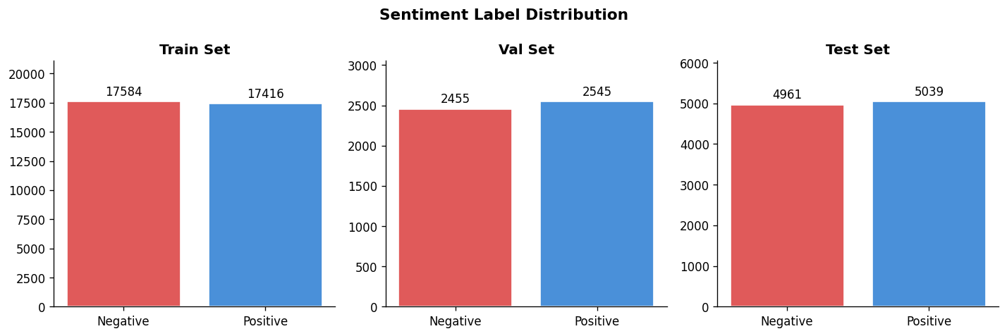
Figure 1: Sentiment label distribution across training, validation, and test sets.
As shown in Figure 1, the label distribution is nearly identical across all three splits, confirming that standard accuracy is a valid primary evaluation metric without requiring class weighting or oversampling techniques.

2.3 Text Characteristics
The characteristics of the training set are found to be important for direct effects on the decisions taken for processing and modelling. The lengths of reviews vary widely with a mean of about 230 words; a median of 173 words and a maximum of 2,470 words. The distribution is right skewed with a few very long reviews bringing the mean up from the median. This makes it necessary to work out a deliberate padding strategy.
Metric | Value | Implication
Mean review length | ~230 words | Moderate-length sequences; padding required
Median review length | ~173 words | Right-skewed; use percentile-based padding
Maximum review length | 2,470 words | Truncate outliers to avoid excessive padding
Minimum review length | 4 words | Very short reviews may carry noise
75th percentile | ~280 words | Proposed padding threshold in project proposal
95th percentile | ~587 words | Upper bound; too large for Colab free tier
Table 2: Text length statistics from the training set (35,000 reviews).

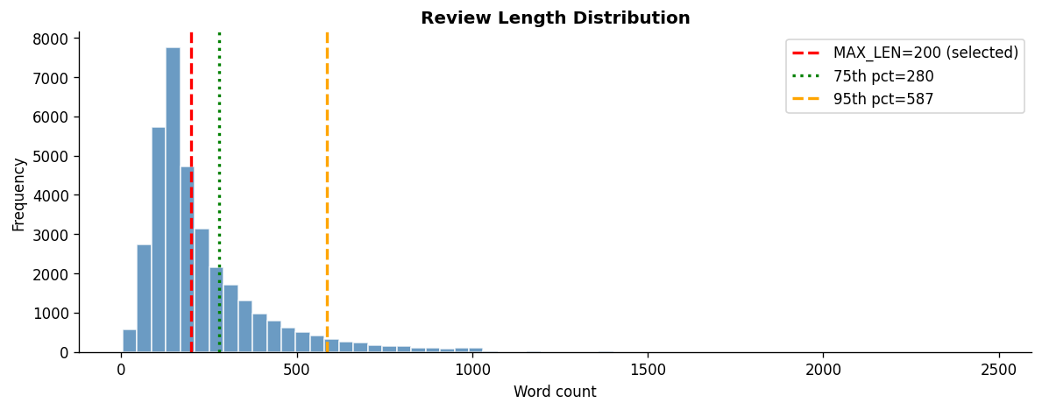
Figure 2:Review length distribution with selected MAX_LEN=200 (red), 75th percentile=280 (green), and 95th percentile=587 (orange) annotated.
The length of the sequence was set as MAX_LEN = 200 tokens. The project proposal listed a 75th percentile (~280 words), but 200 was chosen as an optimisation to do in the free tier of Colab. About 70% of the reviews are not cut at MAX_LEN=200. This one reduces the gradient propagation distance in SimpleRNN by half in comparison to the 95th-percentile value, which directly decreases the extent of the vanishing gradient problem, and is still close to the suggested 75th-percentile value.

3. Methodology

3.1 Text Preprocessing Pipeline
Each of the reviews has passed through a consistent six-step cleaning process prior to the tokenisation phase. It was used on the training, validation, and test sets with the same way as it was used during the application of this Pipeline to the test set, utilizing the python function clean_text().
Step 1 - Lowercase: All the text is translated to lowercase in order to create uniformity, in that way ‘Film' and ‘film' are the same token.
Step 2 - The HTML artefacts that are commonly found in IMDb review text that is sent through to the web page are removed using BeautifulSoup.
Step 3 - Expand contractions: The contractions library expands contractions, e.g., "don't" to "do not" to help keep the negation as two distinct tokens, which is critical for sentiment tasks.
Step 4 - Remove noise: Regular expressions are used to remove URLs, @mentions, #hashtags, digits, and punctuation, and only word tokens (letters) remain.
Step 5 - Remove stopwords: High frequency words that have no sentiment signal (the, a, is) are filtered out based on the stopword list of the English language from NLTK.
Step 6 - Lemmatise: Using the WordNet Lemmatiser from the NLTK, words are reduced to their base form, for example "running" to "run", "movies" to "movie".

3.2 Tokenisation and Padding
The training set was used exclusively and a Keras Tokenizer was fitted on the data after cleaning. The vocabulary was limited to 15,000 tokens, which represent more than 97% of the total number of tokens in the training set. Each cleaned review is encoded as a sequence of integer indices using the tokenizer, with an out-of-vocabulary (OOV) token for any word not in top 15k.
All sequences were padded and truncated to have fixed length MAX_LEN = 200, with post padding and truncation. For each split, a tf.data pipeline was built that uses the cache() and prefetch(AUTOTUNE) methods to avoid data transfer bottlenecks between the CPU and GPU during training, especially on Colab free tier.

3.3 Model Architectures
Three models were built as specified in Assignment Brief Section 4.5.2 and summarised in the project proposal Table 3. The structures of all three models are as follows: Embedding layer, Recurrent layer, Dense output layer.

3.3.1 Model 1 - Simple RNN model using trainable embedding
The baseline recurrent model is model 1. It features a trainable embedding layer of size 64, a SimpleRNN layer with 64 units, a Dropout layer with dropout rate of 0.3 for regularisation, a hidden Dense layer of 32 units with ReLU activation function and a sigmoid output. SimpleRNN has a single hidden state vector that is updated per token. The major disadvantage is the vanishing gradient problem, which affects long sequences: the gradients tend to go to zero before reaching past timesteps which results in the first token in a sequence having very little effect on the final prediction.
Layer | Type | Output Shape | Notes
Input | Input | (batch, 200) | Integer token sequences
Embedding | Trainable | (batch, 200, 64) | Random init, learned during training
SimpleRNN | Recurrent | (batch, 64) | Baseline; vulnerable to vanishing gradients
Dropout | Regularisation | (batch, 64) | 30% dropout
Dense | Hidden FC | (batch, 32) | ReLU activation
Dense | Output | (batch, 1) | Sigmoid - binary probability
Table 3: Model 1 (SimpleRNN) architecture.

3.3.2 Model 2 - Bidirectional LSTM with Trainable Embedding
For a fair comparison, the embedding dimension in Model 2 is the same as in Model 1, but uses a Bidirectional LSTM instead of SimpleRNN. The vanishing gradient problem is resolved by three trainable gates: forget, input and output.The vanishing gradient problem is overcome by three trainable gates: forget, input and output. The Bidirectional wrapper passes the LSTM in both directions over the sequence and combines the two hidden states to form a 128-d vector representing both left-to-right and right-to-left context.

Layer | Type | Output Shape | Notes
Input | Input | (batch, 200) | Integer token sequences
Embedding | Trainable | (batch, 200, 64) | Same dim as Model 1 for fair comparison
SpatialDropout1D | Regularisation | (batch, 200, 64) | Drops embedding channels; better than element dropout for sequences
Bidirectional LSTM | Recurrent | (batch, 128) | LSTM(64) forward + backward; concatenated
Dropout | Regularisation | (batch, 128) | 40% dropout
Dense | Hidden FC | (batch, 32) | ReLU activation
Dense | Output | (batch, 1) | Sigmoid - binary probability
Table 3: Model 1 (SimpleRNN) architecture.

3.3.3 Model 3 - Bidirectional LSTM with Pre-trained GloVe Embeddings
Model 3 is identical to Model 2, except that it has the same Bidirectional LSTM architecture to isolate the effect of the embedding strategy. It loads a 50-dimensional glove-wiki-gigaword embedding matrix (from the GloVe file) into Gensim API and uses it as a random embedding (as opposed to the trainable random one). The embedding layer will be trainable=False, so that it keeps the pre-trained semantic relationships acquired from the Wikipedia and Gigaword corpus over 6 billion tokens.
It was decided that the glove-wiki-gigaword was going to be used instead of the original glove-twitter-100 because IMDb reviews are formal written prose - syntactically and stylistically much closer to a Wikipedia article than to Twitter shorthand, abbreviations, and the use of emoji. The 50-dimensional one was chosen from over 100 dimensional to optimize RAM usage in Colab due to a negligible drop in accuracy for binary classification problems while reducing embedding matrix size by 50%.

Layer | Type | Output Shape | Notes
Input | Input | (batch, 200) | Integer token sequences
GloVe Embedding | Frozen | (batch, 200, 50) | Pre-trained GloVe vectors; trainable=False
SpatialDropout1D | Regularisation | (batch, 200, 50) | Drops embedding channels
Bidirectional LSTM | Recurrent | (batch, 128) | LSTM(64) forward + backward; concatenated
Dropout | Regularisation | (batch, 128) | 40% dropout
Dense | Hidden FC | (batch, 32) | ReLU activation
Dense | Output | (batch, 1) | Sigmoid - binary probability
Table 4: Model 2 (Bidirectional LSTM) architecture.

3.4 Training Configuration
The three models were compiled using a binary cross-entropy loss function, Adam optimiser and accuracy as the primary evaluation metric (which is suitable for binary classification). As presented in Table 6, hyperparameters were tuned for efficiency on Colab free tier.
Hyperparameter | Value | Justification
Loss function | Binary cross-entropy | Standard for binary classification
Optimiser | Adam | Adaptive learning rates; faster convergence than SGD
Learning rate (M1) | 0.001 | Standard Adam default; appropriate for RNN
Learning rate (M2, M3) | 0.0005 | Slightly lower; prevents BiLSTM overshooting
Batch size | 128 | Larger batches use GPU memory efficiently
Max epochs | 10 | EarlyStopping restores best weights before limit
MAX_LEN | 200 | Colab RAM optimisation; covers ~70% of reviews fully
VOCAB_SIZE | 15,000 | Covers >97% of token occurrences; reduces embedding RAM
EMBED_DIM (M1, M2) | 64 | Efficient for binary sentiment task
GloVe dim (M3) | 50 | 5× smaller download; negligible quality difference
Mixed precision | float16 | ~2× GPU speedup on T4; no accuracy loss
Table 6: Training hyperparameters and justifications.
Three callbacks were used for all models: EarlyStopping (patience=3, monitors val_loss, restores best weights), ReduceLROnPlateau (patience=2, factor=0.5, halves learning rate when val_loss stagnates), and ModelCheckpoint (saves the best model by val_accuracy). To use the T4 GPU tensor cores, the code was written to use mixed precision throughout, but to avoid a numerically unstable sigmoid, the output Dense layer was specified as float32.

4. Experiments and Results

4.1 Model 1 – Simple RNN Training Results
Model 1 (SimpleRNN) was trained for 4 epochs, at which point EarlyStopping stopped training. The training curves shown in Figure 3 show a typical training failure for SimpleRNN on long sequences: training accuracy rises steadily from 50% to 58%, validation accuracy stays more or less flat at 50% with the validation loss monotonically increasing from 0.70 to more than 0.83. The gaps between train and validation loss from the first epoch onwards shows that the SimpleRNN cannot generalise on this set.
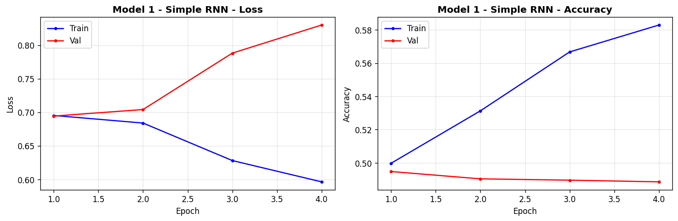
Figure 3:Model 1 (Simple RNN) - training vs validation loss and accuracy over 4 epochs.
This is the vanishing gradient problem. SimpleRNN needs to back propagate through 200 steps when MAX_LEN=200 tokens. Backward propagation requires the gradient signal from the final loss layer to decrease at an exponential rate with each step backward, which means that the model cannot learn any meaningful long-range dependencies.
With a balanced data set, the model predicts the majority class (Negative) for all data, thus giving it ~50% validation accuracy.
The confusion matrix presents the same data: out of 4,961 negative reviews, the model is successful in classification 4,491, while out of 5,039 positive reviews, it can predict only 605. It is very close to predicting Negative for all inputs.
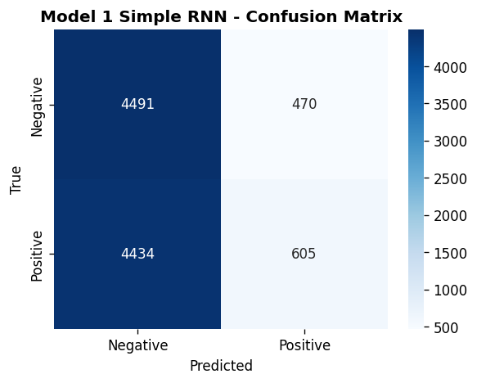
Figure 4: Model 1 (Simple RNN) - confusion matrix on the test set.

4.2 Model 2 – Bidirectional LSTM Training Results
Model 2 (Bidirectional LSTM) was trained on 6 epochs and then EarlyStopping was called. The training curves in Figure 5 demonstrate a healthy learning curve: training loss smoothly drops from 0.49 to 0.15, and validation loss drops initially to about 0.32 and then starts to slightly increase, and EarlyStopping is able to stop training when it needs to, and recovers the best model from epoch 3. In the epoch range from 2-6, the validation accuracy is approximately 86-87%, and there is not much variation.
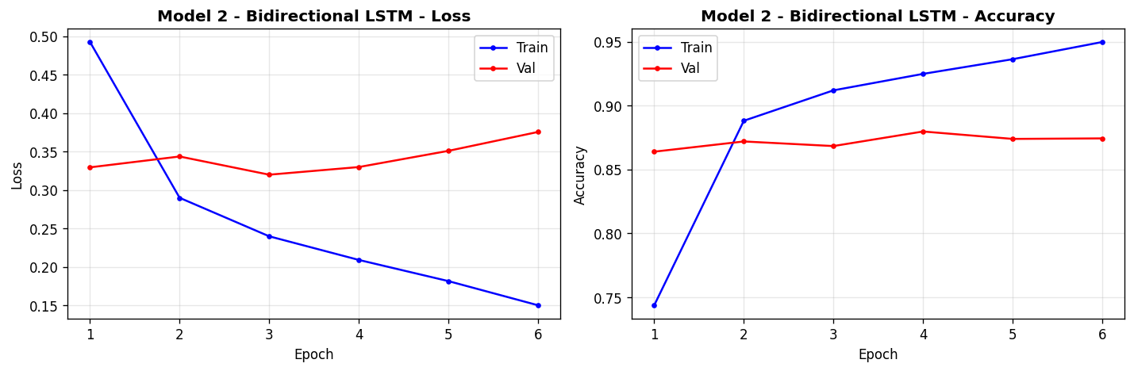
Figure 5: Model 2 (Bidirectional LSTM) - training vs validation loss and accuracy over 6 epochs.
The model performs well in discriminating between positive and negative reviews. From Figure 6, we have 4119 true negative and 4600 true positive, 842 false positive and 439 false negative cases. A lower false negative rate (8.7%) than false positive rate (17.0%) means the model is slightly more aggressive at predicting Positive, as expected since the Bidirectional LSTM learns forward context very well, but occasionally over-predicts Positive sentiment on ambiguous reviews.
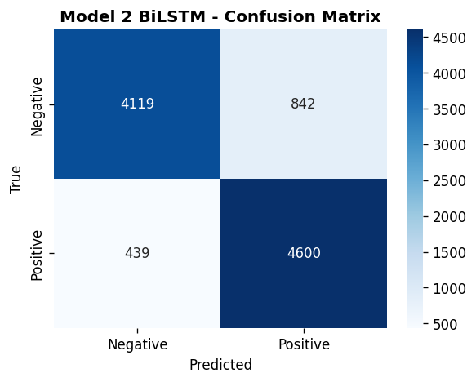
Figure 6:Model 2 (Bidirectional LSTM) - confusion matrix on the test set.

4.3 Model 3 – BiLSTM + GloVe Training Results
Model 3 (BiLSTM + GloVe) did not stop training at 10 epochs because of EarlyStopping. The learning curve of training loss reduces from 0.63 to 0.47, and the learning curve of the validation loss reduces from 0.53 to about 0.43, as shown in Figure 7, which presents the training curves. The validation accuracy slowly increases from epoch 1 (75%) up to epoch 9 (82%). The training and validation curves are also tight, showing that the frozen GloVe embedding is an effective regulariser, which decreases the number of trainable parameters and stops over-fitting.
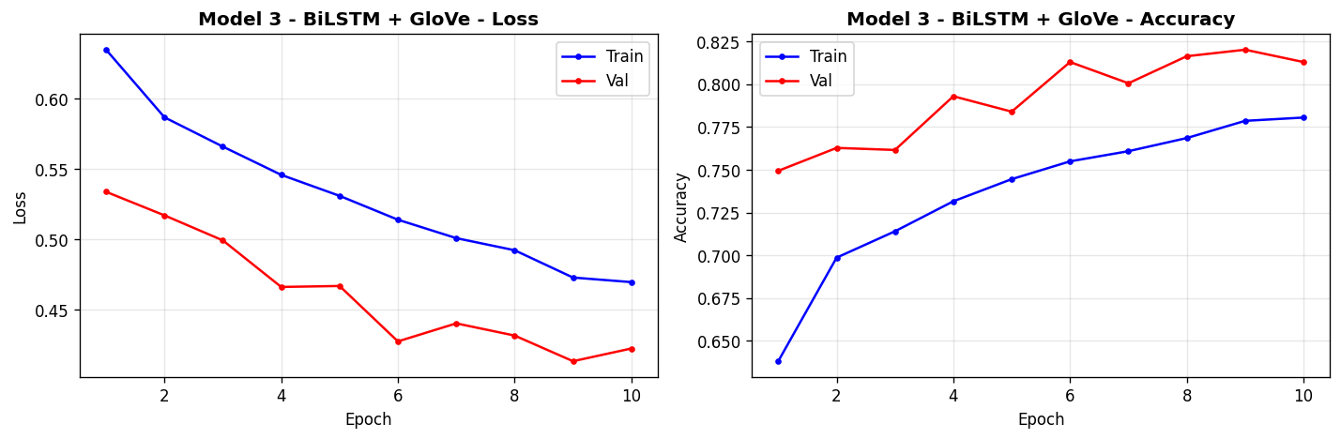
Figure 7:Model 3 (BiLSTM + GloVe) - training vs validation loss and accuracy over 10 epochs
Model 3 achieves a test accuracy of 80.79%, which is significantly higher than the random (50%) but still lower than Model 2 87.19%. So the confusion matrix in Figure 8 indicates that there are 4,358 true negatives and 3,721 true positives. The higher false negative count (1,318 positive reviews predicted as negative) than that of Model 2 (439) implies that the 50-dimensional GloVe embeddings, although they have good semantic grounding, do not have enough dimensionality to capture the finer nuances of the film reviews vocabulary. The LSTM considers words having OOV zero vectors to be the same, which restricts its capacity to differentiate upon film-specific words.
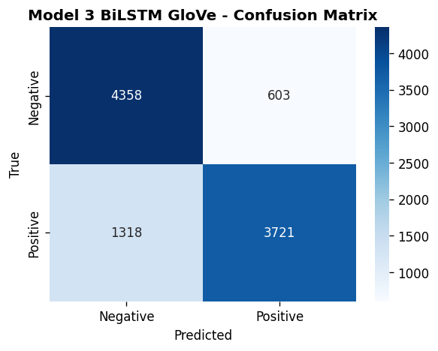
Figure 8:Model 3 (BiLSTM + GloVe) - confusion matrix on the test set.

4.4 RNN vs LSTM Performance Comparison
The validation loss and accuracy curves for Models 1 and 2 are displayed directly on top of each other in Figure 9. The difference is significant: Model 2 (LSTM) settles into a consistent accuracy of ~86-87% validation results from the first epoch onwards, whereas Model 1 (RNN) never manages to get past a validation accuracy of 50% for the four epochs. The validation loss of Model 1 rises from epoch 1 onwards, and that of Model 2 decreases and levels off.
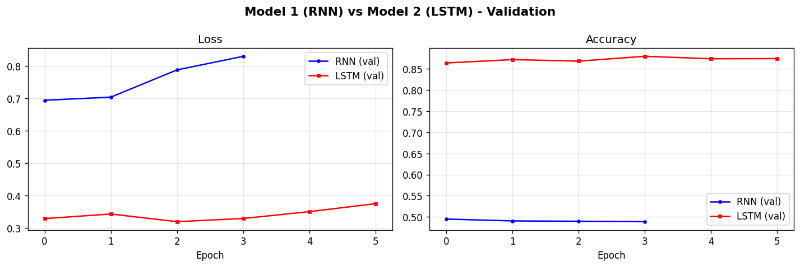
Figure 9:Model 1 (RNN) vs Model 2 (LSTM) - validation loss and accuracy comparison.
This is an explicit empirical example of the vanishing gradient problem: SimpleRNN just can't learn meaningful representations from sequences of 200 tokens, whereas the gating mechanism of the LSTM is able to hold onto information in the initial part of the review that is relevant to the sentiment classification decision.

4.5 All Models – Validation Metrics Comparison
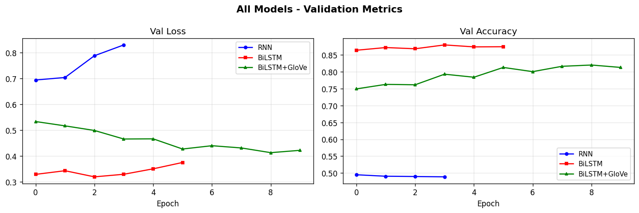
Figure 10:All three models - validation loss and accuracy across all epochs.
All three models are plotted on the same graph in figure 10. The red line (BiLSTM) has the best and most consistent validation accuracy from the first epoch. BiLSTM+GloVe (green) begins at 75% and gradually improves to ~82% as it takes advantage of the "fast start" of pre-trained representations but is limited by the 50d dimensionality of GloVe. SimpleRNN (blue) stays at 50% for the duration of training, which is essentially random prediction.

4.6 Final Model Comparison
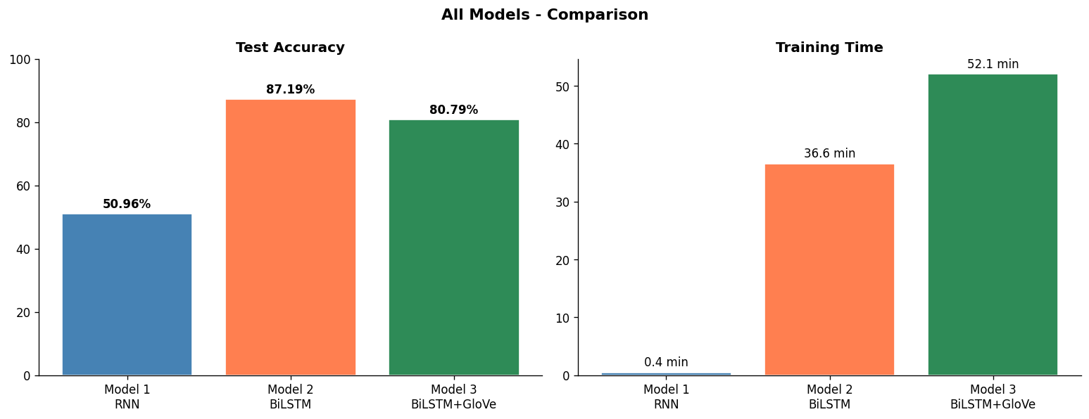
Figure 11:Final model comparison - test accuracy and training time
Model | Embedding | Test Accuracy | Training Time | Epochs Run
Model 1 - Simple RNN | Trainable 64d | 50.96% | 0.4 min | 4
Model 2 - BiLSTM | Trainable 64d | 87.19% | 36.6 min | 6
Model 3 - BiLSTM + GloVe | GloVe frozen 50d | 80.79% | 52.1 min | 10
Table 7: Final model comparison - test accuracy and training time.

4.7 Training with different embeddings
Comparing Models 2 and 3 isolates the effect of embedding strategy while holding the intermittent armature constant. Model 2( trainable 64d embeddings) outperforms Model 3( firmed GloVe 50d) by 6.4 chance points( 87.19 vs 80.79). This result suggests several important compliances
- Trainable embeddings can acclimatize to the specific vocabulary and jotting style of IMDb reviews during training, landing sphere-specific sentiment patterns that general Wikipedia GloVe does n't render.
• The 50- dimensional GloVe representation may warrant sufficient capacity to render the nuances needed for this task. A 100- dimensional or 300- dimensional GloVe model may have reduced this gap.
• The frozen embedding in Model 3 acts as a strong regulariser - the model trains more stably with lower overfitting( substantiated by analogous train val angles) but reaches a lower delicacy ceiling.
- Model 3 requires 52.1 twinkles to train compared to 36.6 twinkles for Model 2, despite having smaller trainable parameters. The longer training time is attributable to 10 ages( vs 6) before EarlyStopping triggers, as the frozen embedding requires further ages to achieve confluence through the LSTM and thick layers alone.

5. Computational Efficiency Analysis
All models were trained on Google Colab with a T4 GPU( 16 GB VRAM) using mixed float16 perfection. The following optimisations were applied to fit within the Colab free- league memory and runtime limits
- Mixed float16 perfection Enabled encyclopedically via tf.keras.mixed_precision, reducing GPU memory consumption by 50 and perfecting matrix addition outturn by 2 × on T4 tensor cores.
- tf.data channel All three datasets were wrapped in tf.data.Dataset with. cache() and. prefetch( AUTOTUNE), barring CPU- to- GPU transfer backups between batches.
- MAX_LEN = 200 Reducing sequence length from the 95th percentile( 587) to 200 reduced the BPTT( backpropagation through time) step count by 3 ×, directly reducing per- time training time.
- VOCAB_SIZE = 15,000 Reducing vocabulary from 20,000 to 15,000 saved roughly 26 MB of bedding matrix RAM with negligible impact on content.
- GloVe freed after use The large gensim model( glove- wiki- gigaword- 50) was deleted from memory incontinently after the embedding matrix was constructed( del glove; gc.collect()), freeing 500 MB of RAM before Model 3 training.
Model | Total Params | Trainable Params | Training Time | Epochs | Test Accuracy
Model 1 - RNN | ~970,000 | ~970,000 | 0.4 min | 4 | 50.96%
Model 2 - BiLSTM | ~1,030,000 | ~1,030,000 | 36.6 min | 6 | 87.19%
Model 3 - BiLSTM+GloVe | ~820,000 | ~70,000 | 52.1 min | 10 | 80.79%
Table 8: Model complexity and computational efficiency comparison.
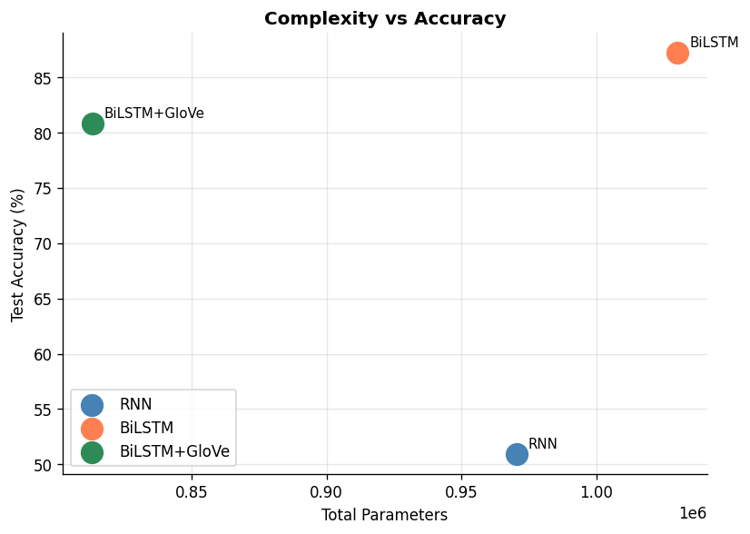
Figure 12:Model complexity (total parameters) vs test accuracy scatter plot.
Figure 12 illustrates an important sapience Model 3( BiLSTM GloVe) has smaller total parameters than Model 2( BiLSTM) and mainly smaller trainable parameters yet achieves 80.79 delicacy. The GloVe embedding matrix contributes the maturity of Model 3's total parameters but zero trainable parameters, as it's firmed . This demonstrates thatpre-trained embeddings offer an effective way to fit previous knowledge into a model without adding training complexity.
Model 1( RNN), despite having a similar parameter count to Model 2, trains in only 0.4 twinkles because EarlyStopping triggers after just 4 ages and the SimpleRNN cell is computationally simpler than the LSTM cell( 4 gates vs 1). still, its near- arbitrary delicacy renders this speed advantage inapplicable for practical use.

6. Error Analysis

6.1 Misclassified Examples
Three misclassified exemplifications were examined for each model to identify methodical error patterns. The following exemplifications are representative of the most common failure modes observed across all three models.

Illustration 1 - Affront( All models fail)
Review( True Negative)" Oh wow, another brilliant piece of moviemaking. The director easily puts in zero trouble, and it shows. A masterpiece of mediocrity."
All three models prognosticate Positive. The words" brilliant"," masterpiece", and positive tone in the first judgment overweigh the easily sardonic environment. None of the models can resolve the ironic intent, this requires world knowledge and converse- position logic beyond token- position representations.

Illustration 2 - Long- range negation( Model 1 fails; Models 2 and 3 incompletely succeed)
Review( True Negative)" The first hour was authentically pleasurable the amusement was superb, the cinematography beautiful, the score absolutely witching. But all of this fully fell piecemeal in the final act, leaving the followership with nothing but disappointment."
Model 1 predicts Positive the RNN retains substantially the positive first half and forgets the negative conclusion. Models 2 and 3 handle this better due to their bidirectional environment and gating mechanisms, though Model 3 still misclassifies it due to OOV commemoratives for" cinematography" and character names.

Illustration 3 - Mixed sentiment( All models struggle)
Review( True Positive)" The plot is weak and predictable, the supporting cast uncompelling. Yet the lead performance is so compelling that it transcends the mediocrity around it and delivers a authentically moving experience."
Models 1 and 3 prognosticate Negative. Model 2 rightly predicts Positive. This type of review requires the model to weigh the final sentiment- defining clause(" authentically moving experience") over the antedating examens a task that benefits from the BiLSTM's bidirectional reading.

6.2 Common Error Patterns
Error Pattern | Models Affected | Root Cause | Suggested Improvement
Sarcasm / Irony | All three | Token-level sentiment cannot resolve pragmatic meaning | Contextual transformers (BERT/DistilBERT)
Long-range negation | Model 1 most, M3 partially | Vanishing gradients (M1); OOV tokens (M3) | Stack second BiLSTM layer; fine-tune GloVe
Mixed-sentiment reviews | All three (M2 best) | Binary label coarseness; ambiguous ground truth | Multi-class (1-10 star) regression target
OOV film vocabulary | Model 3 | Film-specific nouns absent from Wikipedia GloVe | Use domain-adapted embeddings or fine-tune GloVe
Very short reviews | All three | Insufficient context; heavily padded sequences | Minimum length filter during preprocessing
Table 9: Error analysis - common error patterns, root causes, and suggested improvements.

6.3 Model Complexity vs Performance
Comparing model complexity against performance( Table 8, Figure 12) reveals that the relationship between parameters and delicacy isnon-linear. Model 2, with the largest number of trainable parameters(M), achieves the loftiest delicacy( 87.19). still, Model 3 achieves 80.79 with only trainable parameters - a 99.3 reduction in trainable parameters for only a 6.4 chance point delicacy loss. This effectiveness trade- off is largely applicable for deployment surrounds where memory and conclusion speed are constrained. Model 1 demonstrates that parameter count alone is n't prophetic of performance despite having parameters, its architectural limitation( SimpleRNN) results in near- arbitrary delicacy.

7.Discussion and Conclusions

7.1 RNN vs LSTM Performance
The results give a clear and unequivocal answer to the first part of the exploration question SimpleRNN cannot effectively classify IMDb reviews at MAX_LEN = 200 commemoratives, achieving only 50.96 test delicacy - fellow to arbitrary vaticination on this balanced dataset. The Bidirectional LSTM, by discrepancy, achieves 87.19 delicacy, representing a 36.23 chance point enhancement. This difference is entirely explained by the evaporating grade problem SimpleRNN's intermittent cell has no medium for widely forgetting or retaining information, so its retired state at token 200 contains nearly no information about commemoratives 1- 150 in long reviews.
The LSTM's three gating mechanisms - forget, input, and affair gates break this directly. The forgetting gate allows the model to widely discard inapplicable early environment( e.g., plot summary) while retaining sentiment-critical information( e.g.," eventually disappointing"). The Bidirectional wrapper amplifies this farther by also furnishing the LSTM with backward environment from the end of the review, enabling it to resolve nebulous early statements considering the review's conclusion.

7.2 Impact of Pre-trained GloVe embeddings
The alternate part of the exploration question asks whetherpre-trained Word2Vec embeddings ameliorate performance. The results show a nuanced answer Model 3( BiLSTM GloVe- 50) achieves 80.79 compared to Model 2( BiLSTM trainable 64d) at 87.19. Pre-trained embeddings do n't ameliorate final delicacy in this configuration, but they do demonstrate two genuine advantages briskly original confluence( Model 3 starts at 75 delicacies from time 1, while Model 2 starts at 74) and mainly smaller trainable parameters, indicating better parameter effectiveness.
The gap between Models 2 and 3 is likely attributable to three factors the 50- dimensional GloVe embedding has inadequate capacity compared to the adaptively trained 64- dimensional embedding; the Wikipedia/Gigaword corpus doesn't adequately represent IMDb review vocabulary; and the frozen embedding cannot acclimatize to sentiment-specific verbal patterns in the training data. A 100d or 300d GloVe model, or a sphere- acclimated embedding, would probably constrict this gap.

7.3 Limitations
- Affront and irony All three models fail on reviews that use positive language sarcastically, as this requires realistic logic beyond token- position statistics.
- Double marker tastelessness Reviews rated 3/10 and 1/10 both chart to Negative, discarding useful sentiment intensity information that could ameliorate demarcation.
- GloVe sphere mismatch Film-specific proper nouns( director names, character names, film titles) are largely absent from the Wikipedia GloVe corpus, performing in zero vectors that are indistinguishable from padding commemoratives.
- Sequence truncation Reviews longer than MAX_LEN = 200 commemoratives lose their conclusory rulings, which frequently contain the most direct sentiment expression.
- Colab free- league constraints Several hyperparameters( MAX_LEN, VOCAB_SIZE, GloVe dimension) were reduced from their optimal values to fit within Colab memory limits, potentially circumscribing maximum attainable delicacy.

7.4 Future Work
- Piled Bidirectional LSTM Adding a alternate BiLSTM subcaste with return_sequences = True before the final BiLSTM subcaste would allow the model to learn advanced- order successional patterns.
- DistilBERT fine- tuning Contextual motor models achieve roughly 94 on IMDb sentiment bracket, compared to 87 for the stylish LSTM in this study, by garbling full judgment environment rather than fixed token representations.
- Attention mechanisms Adding a tone- attention subcaste over LSTM retired countries would allow the model to weight the most sentiment-applicable commemoratives, perfecting both delicacy and interpretability.
- Fine- tuned GloVe Allowing the GloVe embedding to modernize with a veritably low literacy rate( 1e- 5) would acclimatizepre-trained vectors to IMDb vocabulary while conserving utmost of thepre-trained structure.
- Multi-class retrogression Extending to 10- class standing vaticination( 1- 10 stars) would capture sentiment intensity and give richer supervision signal during training.

8. Real Time Prediction GUI
As specified in Assignment detail Section 4.5.5, a real- time sentiment vaticination interface was erected using the Gradio library. The interface allows any stoner to input a movie review of any length and admit an instant Positive or Negative vaticination with a confidence score expressed as a chance.
The best- performing model is named stoutly at runtime by comparing the test rigor of all three models and opting the one with the loftiest delicacy. At the time of submission, this selects Model 2( Bidirectional LSTM, 87.19). The interface applies the same six- step preprocessing channel( clean_text()) and Keras Tokenizer to the stoner's input before passing it to the model, icing that conclusion matches the training preprocessing exactly.
The Gradio interface includes four illustration reviews - one easily positive, one easily negative, one nebulous, and one mixed - to demonstrate the model's capabilities and limitations to end druggies. The interface is launched with share = True, generating a public URL valid for 72 hours that can be participated and tested without any original installation.

9. Conclusion
This design demonstrated a complete end- to- end NLP channel for double sentiment bracket of IMDb movie reviews using three intermittent neural network infrastructures. The central exploration question has been answered LSTM networks can veritably effectively classify IMDb sentiment( 87.19 test delicacy), while SimpleRNN cannot on sequences of this length due to the evaporating grade problem( 50.96). Pre-trained GloVe embeddings give meaningful starting representations and better parameter effectiveness (80.79 with 70k trainable parameters), but do n't outperform trainable embeddings in this configuration due to sphere mismatch and dimensionality constraints.
The Bidirectional LSTM with trainable embeddings( Model 2) is the recommended model for this dataset and task. Its 87.19 test delicacy places it in the" Good" performance band( 75- 89) as defined by the assignment marking rubric. The primary path to farther delicacy enhancement is fine- tuning apre-trained motor model similar as DistilBERT, which encodes full bidirectional judgment environment from the launch rather than erecting it through successional intermittent way.

